1. 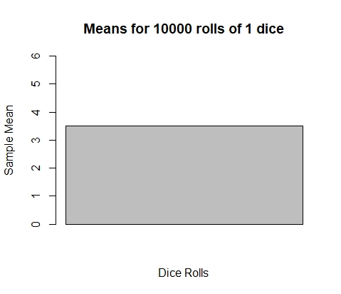  
   [1] 3.5191 (mean)

[1] NA (standard deviation

1. 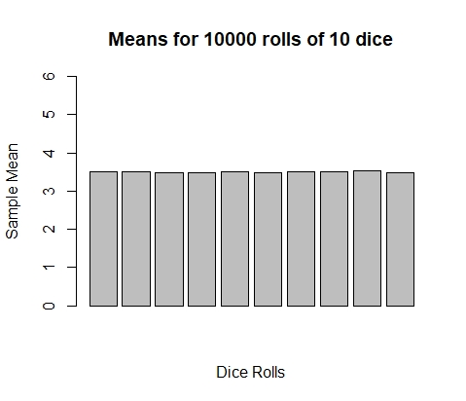  
   [1] 3.49874 (mean)

[1] 0.01421073 (st deviation)

1. 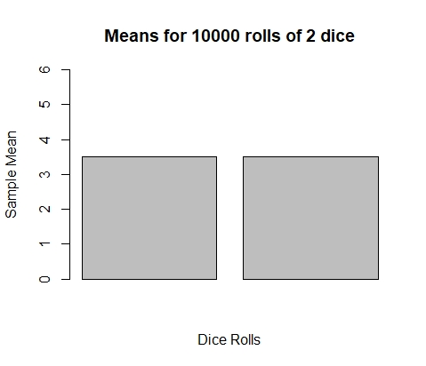  
   [1] 3.507 (mean)

[1] 0.008202439 (st deviation)

1. 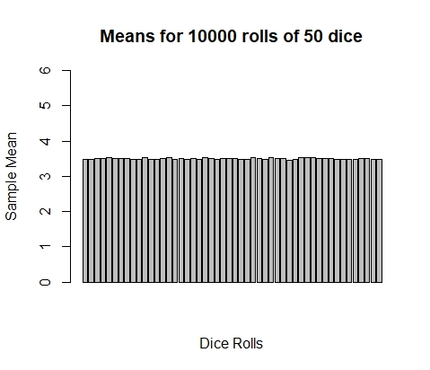  
   [1] 3.501416 (mean)

[1] 0.01806677 (st deviation)

1. 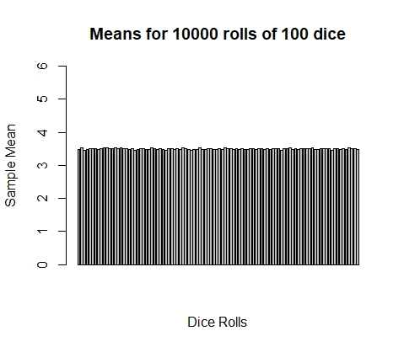  
   [1] 3.497963 (mean)

[1] 0.017703 (st deviation)

the graphs are very comparable since each bar is 10 000 dice rolled for a mean result. The mean generally becomes more closer to 3.5 (but it is always close) and lowers except in the 2 dice example, but that is a chance occurrence.